**Microsoft Power BI Project**

**About :** I have experience in creating visually pleasing Power BI dashboards using various datasets. To ensure data accuracy, I cleaned and transformed the data using Power Query Editor and then used DAX to create new measures and columns. The result is a set of interactive dashboards that provide valuable insights to help inform business decisions. I am excited to continue using my skills in Power BI to create impactful and insightful data visualizations.

**Dashboard snapshots**

**Dashboard#1:**

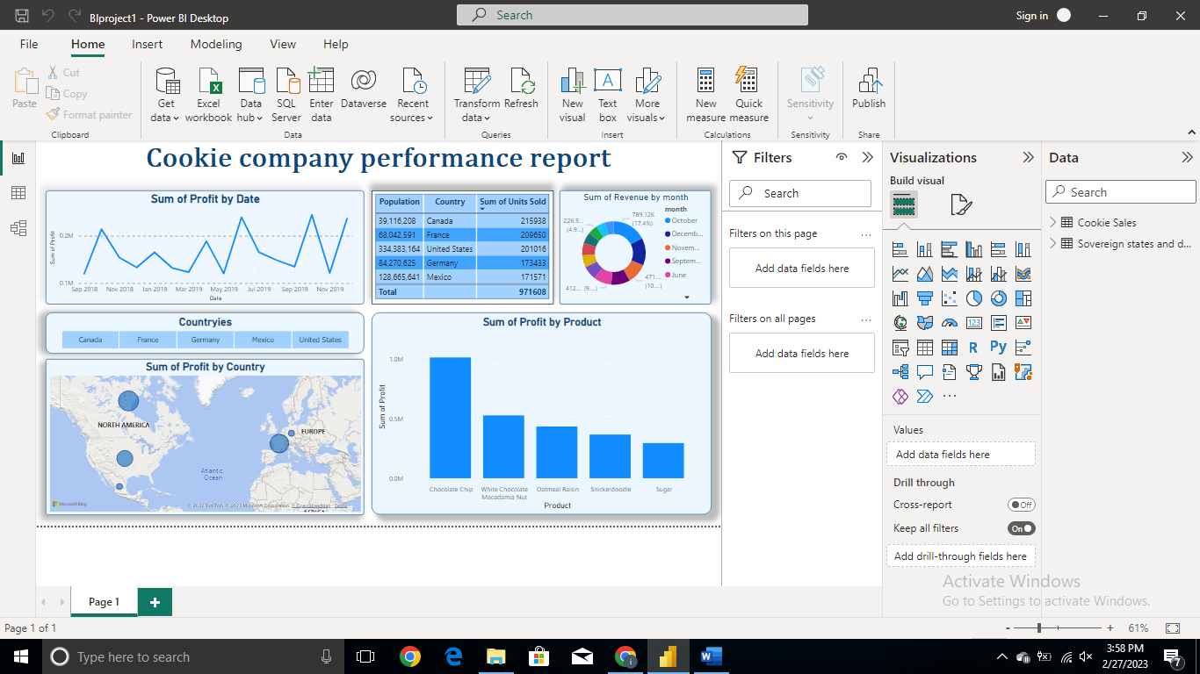

**Dashboard#2:**

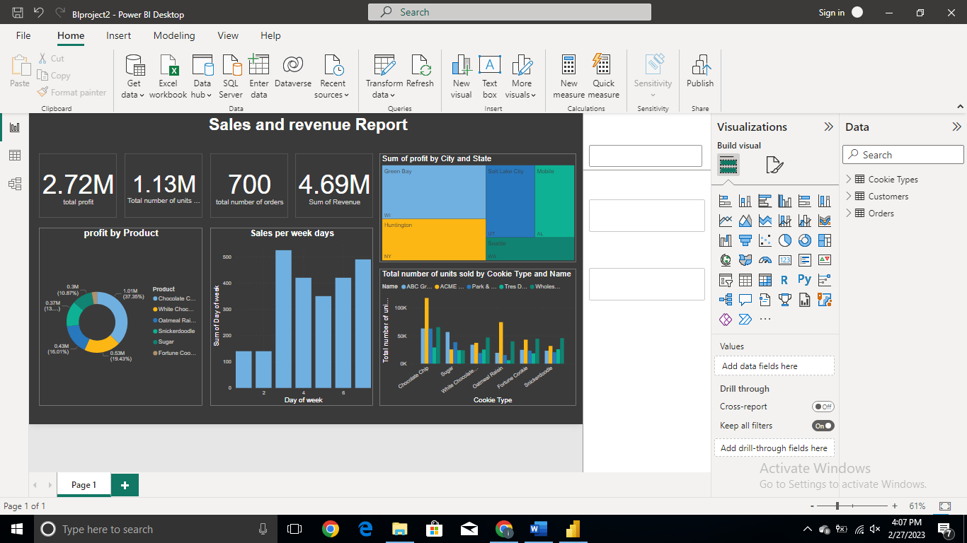

**Dashboard#3:**

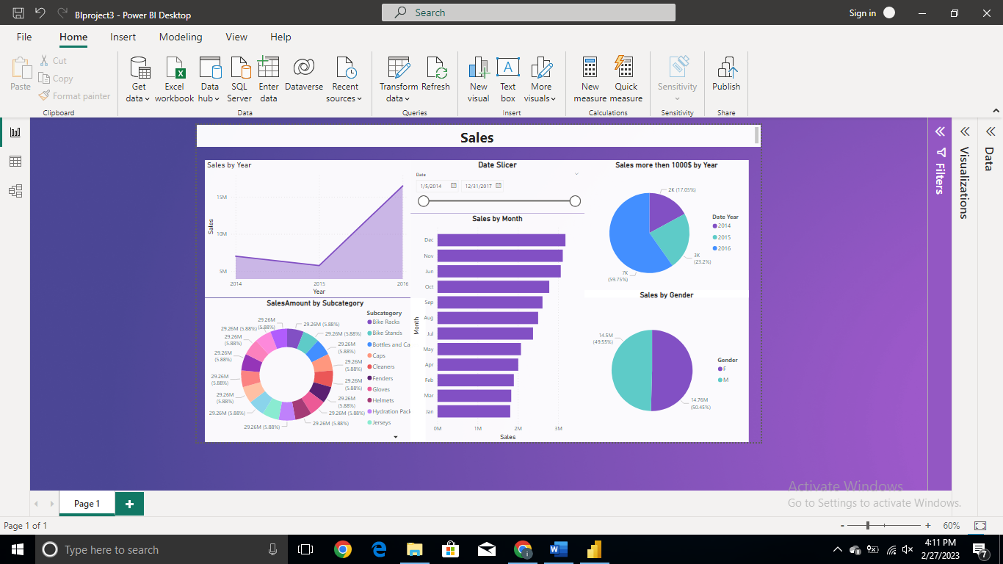

**Dashboard#4:**

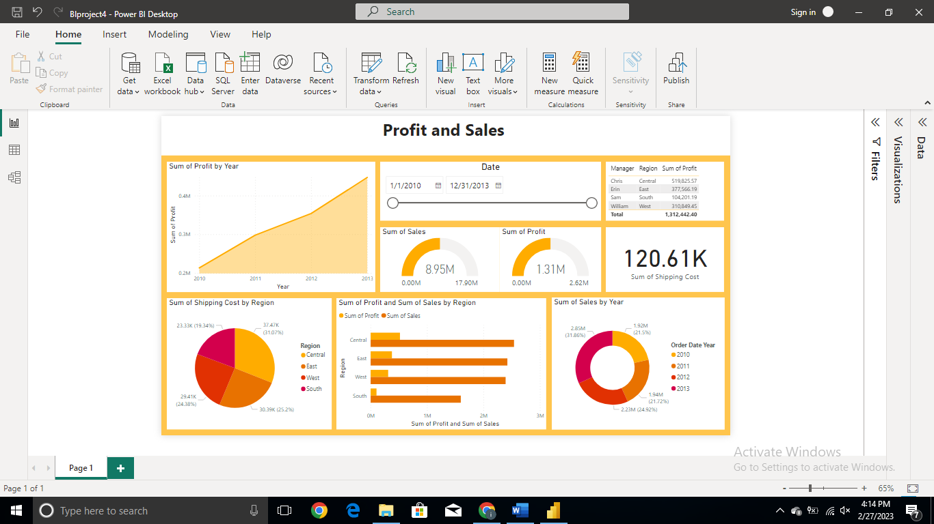

**Dashboard#5:**

